3GPP TS 32.273 V11.0.0 (2012-09)
Technical Specification
3rd Generation Partnership Project;
Technical Specification Group Services and System Aspects;
Telecommunication management;
Charging management;
Multimedia Broadcast and Multicast Service (MBMS) charging
(Release 11)


The present document has been developed within the 3rd Generation Partnership Project (3GPP TM) and may be further elaborated for the purposes of 3GPP.
The present document has not been subject to any approval process by the 3GPP Organizational Partners and shall not be implemented.
This Specification is provided for future development work within 3GPP only. The Organizational Partners accept no liability for any use of this Specification.
Specifications and reports for implementation of the 3GPP TM system should be obtained via the 3GPP Organizational Partners' Publications Offices.

Keywords
UMTS, charging, management, broadcast
3GPP
Postal address

3GPP support office address
650 Route des Lucioles - Sophia Antipolis
Valbonne - FRANCE
Tel.: +33 4 92 94 42 00 Fax: +33 4 93 65 47 16
Internet
http://www.3gpp.org
Copyright Notification
No part may be reproduced except as authorized by written permission.
The copyright and the foregoing restriction extend to reproduction in all media.

© 2012, 3GPP Organizational Partners (ARIB, ATIS, CCSA, ETSI, TTA, TTC).
All rights reserved.
UMTS™ is a Trade Mark of ETSI registered for the benefit of its members
3GPP™ is a Trade Mark of ETSI registered for the benefit of its Members and of the 3GPP Organizational Partners
LTE™ is a Trade Mark of ETSI currently being registered for the benefit of its Members and of the 3GPP Organizational Partners
GSM® and the GSM logo are registered and owned by the GSM Association
Contents
Foreword 5
1 Scope 6
2 References 6
3 Definitions, symbols and abbreviations 7
3.1 Definitions 7
3.2 Symbols 9
3.3 Abbreviations 10
4 Architecture considerations 11
4.1 High level MBMS architecture 11
4.2 MBMS offline charging architecture 11
4.3 MBMS online charging architecture 11
5 MBMS charging principles and scenarios 12
5.1 MBMS charging principles 12
5.1.1 General principles for GPRS 12
5.1.1A General principles for EPS 13
5.1.2 Triggers for generation of charging information 14
5.2 MBMS offline charging scenarios 15
5.2.1 Basic principles 15
5.2.2 Rf message flows 16
5.2.2.1 Broadcast Service 16
5.2.2.1.1 User service charging 16
5.2.2.1.2 Session Start for GPRS 16
5.2.2.1.2A Session Start for EPS 17
5.2.2.1.2B Void 17
5.2.2.1.3 Session Stop for GPRS 18
5.2.2.1.3A Session Stop for E-UTRAN 18
5.2.2.1.3B Void 19
5.2.2.1.4 BM-SC initiated Registration and De-Registration 19
5.2.2.1.5 Session Update for EPS with E-UTRAN and UTRAN 19
5.2.2.2 Multicast Service 20
5.2.2.2.1 Session Start 20
5.2.2.2.2 Session Stop 21
5.2.2.2.3 BM-SC initiated MBMS De-registration 22
5.2.2.2.4 UE Activation 23
5.2.2.2.5 UE Deactivation 24
5.2.3 CDR generation 25
5.2.3.1 CDRs related to MBMS subscribers 25
5.2.3.1.1 Triggers for S-BMSC-CDR charging information collection 25
5.2.3.1.2 Triggers for S-BMSC-CDR Charging Information Addition 25
5.2.3.1.3 Triggers for S-BMSC-CDR closure 25
5.2.3.2 CDRs related to content provider 26
5.2.3.2.1 Triggers for BMSC-CDR charging information collection 26
5.2.3.2.2 Triggers for C-BMSC-CDR Charging Information Addition 26
5.2.3.2.3 Triggers for C-BMSC-CDR closure 26
5.2.4 Ga record transfer flows 27
5.2.5 B_{mb} CDR file transfer 27
5.3 MBMS online charging scenarios 27
5.3.1 Basic principles 27
5.3.2 Ro message flows 27
5.3.2.1 Broadcast Service 27
5.3.2.1.1 User service charging 27
5.3.2.1.2 Session Start 27
5.3.2.1.3 Session Stop 27
5.3.2.1.4 BM-SC initiated Registration and De-Registration 27
5.3.2.2 Multicast Service 28
5.3.2.2.1 Session Start 28
5.3.2.2.2 Session Stop 29
5.3.2.2.3 BM-SC initiated MBMS De-registration 30
5.3.2.2.4 UE Activation 31
5.3.2.2.5 UE Deactivation 32
5.3.3 Credit Control related 33
5.3.3.1 Triggers for stopping for an MBMS service Credit Control session 33
5.3.3.2 Triggers for providing interim information for a MBMS service Credit Control session 33
6 Definition of charging information 34
6.1 Data description for MBMS offline charging 34
6.1.1 Rf message contents 34
6.1.1.1 Summary of Offline Charging Message Formats 34
6.1.1.2 Structure for the Accounting Message Formats 34
6.1.1.2.1 Accounting-Request Message 34
6.1.1.2.2 Accounting-Answer Message 35
6.1.2 Ga message contents 36
6.1.3 CDR description on the B_{mb} interface 36
6.1.3.1 CDR description for subscriber charging 36
6.1.3.2 CDR description for content provider charging 37
6.2 Data description for MBMS online charging 38
6.2.1 Ro message contents 38
6.2.1.1 Summary of Message Formats 38
6.2.1.2 Structure for the Credit Control Message Formats 38
6.2.1.2.1 Credit-Control-Request Message 38
6.2.1.2.2 Credit-Control-Answer Message 39
6.3 MBMS charging specific parameters 40
6.3.1 Definition of the MBMS charging information 40
6.3.1.1 MBMS charging information assignment for Service-Information 40
6.3.1.2 Definition of the MBMS Information 40
6.3.2 Formal parameter description 41
6.3.2.1 MBMS charging information for CDRs 41
6.3.2.2 MBMS charging information for charging events 41
Annex A (informative): Bibliography 42
Annex B (informative): Change history 43

Foreword
This Technical Specification has been produced by the 3rd Generation Partnership Project (3GPP).
The contents of the present document are subject to continuing work within the TSG and may change following formal TSG approval. Should the TSG modify the contents of the present document, it will be re-released by the TSG with an identifying change of release date and an increase in version number as follows:
Version x.y.z
where:
x the first digit:
1 presented to TSG for information;
2 presented to TSG for approval;
3 or greater indicates TSG approved document under change control.
y the second digit is incremented for all changes of substance, i.e. technical enhancements, corrections, updates, etc.
z the third digit is incremented when editorial only changes have been incorporated in the document.

1 Scope
The present document is part of a series of documents that specify charging functionality and charging management in GSM/UMTS networks. The GSM/UMTS core network charging architecture and principles are specified in 3GPP TS 32.240 [1], which provides an umbrella for other charging management TSs that specify:
- the content of the CDRs per domain / subsystem / service (offline charging);
- the content of real-time charging messages per domain / subsystem / service (online charging);
- the functionality of online and offline charging for those domains / subsystems / services;
- the interfaces that are used in the charging framework to transfer the charging information (i.e. CDRs or charging events).
The complete document structure for these TSs is defined in 3GPP TS 32.240 [1].
The present document specifies the Offline and Online Charging description for the Multimedia Broadcast and Multicast Service (MBMS), based on the functional stage 2 description in 3GPP TS 23.246 [200]. This charging description includes the offline and online charging architecture and scenarios specific to MBMS, as well as the mapping of the common 3GPP charging architecture specified in 3GPP TS 32.240 [1] onto MBMS. It further specifies the structure and content of the CDRs for offline charging, and the charging events for online charging. The present document is related to other 3GPP charging TSs as follows:
- The common 3GPP charging architecture is specified in 3GPP TS 32.240 [1];
- The parameters, abstract syntax and encoding rules for the CDRs are specified in 3GPP TS 32.298 [51];
- A transaction based mechanism for the transfer of CDRs within the network is specified in TS 32.295 [54];
- The file based mechanism used to transfer the CDRs from the network to the operator’s billing domain (e.g. the billing system or a mediation device) is specified in 3GPP TS 32.297 [52];
- The 3GPP Diameter application that is used for MBMS offline and online charging is specified in 3GPP TS 32.299 [50].
All terms, definitions and abbreviations used in the present document, that are common across 3GPP TSs, are defined in the 3GPP Vocabulary, 3GPP TR 21.905 [100]. Those that are common across charging management in GSM/UMTS domains or subsystems are provided in the umbrella document 3GPP TS 32.240 [1] and are copied into clause 3 of the present document for ease of reading. Finally, those items that are specific to the present document are defined exclusively in the present document.
Furthermore, requirements that govern the charging work are specified in 3GPP TS 22.115 [102].

2 References
The following documents contain provisions which, through reference in this text, constitute provisions of the present document.
- References are either specific (identified by date of publication, edition number, version number, etc.) or non-specific.
- For a specific reference, subsequent revisions do not apply.
- For a non-specific reference, the latest version applies. In the case of a reference to a 3GPP document (including a GSM document), a non-specific reference implicitly refers to the latest version of that document in the same Release as the present document.
[1] 3GPP TS 32.240: "Telecommunication management; Charging management; Charging architecture and principles".
[2]- [9] Void.
[10] 3GPP TS 32.250: "Telecommunication management; Charging management; Circuit Switched (CS) domain charging".
[11] 3GPP TS 32.251: "Telecommunication management; Charging management; Packet Switched (PS) domain charging".
[12]-[19] Void.
[20] 3GPP TS 32.260: "Telecommunication management; Charging management; IP Multimedia Subsystem (IMS) charging".
[21]-[29] Void.
[30] 3GPP TS 32.270: "Telecommunication management; Charging management; Multimedia Messaging Service (MMS) charging".
[31]-[49] Void.
[50] 3GPP TS 32.299: "Telecommunication management; Charging management; Diameter charging application".
[51] 3GPP TS 32.298: "Telecommunication management; Charging management; Charging Data Record (CDR) parameter description".
[52] 3GPP TS 32.297: "Telecommunication management; Charging management; Charging Data Record (CDR) file format and transfer".
[53] Void.
[54] 3GPP TS 32.295: "Telecommunication management; Charging management; Charging Data Record (CDR) transfer".
[55]-[99] Void.
[100] 3GPP TR 21.905: "Vocabulary for 3GPP specifications".
[101] Void.
[102] 3GPP TS 22.115: "Service aspects; Charging and billing".
[103]-[199] Void.
[200] 3GPP TS 23.246: "Multimedia Broadcast/Multicast Service (MBMS); Architecture and functional description".
[201] 3GPP TS 22.146: "Multimedia Broadcast/Multicast Service (MBMS); Stage 1".
[202] 3GPP TS 22.246: "Multimedia Broadcast/Multicast Service (MBMS) user services; Stage 1".
[203] 3GPP TS 26.346: "Multimedia Broadcast/Multicast Service (MBMS); Protocols and codecs".
[204] 3GPP TS 29.061: "Interworking between the Public Land Mobile Network (PLMN) supporting packet based services and Packet Data Networks (PDN)".

3 Definitions, symbols and abbreviations

3.1 Definitions
For the purposes of the present document, the terms and definitions given in 3GPP TR 21.905 [100], 3GPP TS 32.240 [1], 3GPP TS 23.246 [200] and the following apply:
2G- / 3G-: prefixes 2G- and 3G- refer to functionality that supports only GSM or UMTS, respectively, e.g. 2G-SGSN refers only to the GSM functionality of an SGSN
accounting: process of apportioning charges between the Home Environment, Serving Network and Subscriber
Advice of Charge (AoC): real-time display of the network utilization charges incurred by the Mobile Station
The charges are displayed in the form of charging units. If a unit price is stored by the MS then the display may also include the equivalent charge in the home currency.
AoC service: combination of one or more services, both basic and supplementary, together with a number of other charging relevant parameters to define a customized service for the purpose of advice of charge
billing: function whereby CDRs generated by the charging function(s) are transformed into bills requiring payment
Billing Domain: part of the operator network, which is outside the core network, that receives and processes CDR files from the core network charging functions
It includes functions that can provide billing mediation and billing or other (e.g. statistical) end applications. It is only applicable to offline charging (see "Online Charging System" for equivalent functionality in online charging).
CDR field categories: the CDR fields are defined in the present document. CDR fields may be operator provisionable and are divided into the following categories:
- Mandatory (M): field that shall always be present in the CDR.
- Conditional (C): field that shall be present in a CDR if certain conditions are met.
- Operator Provisionable: Mandatory (OM): field that, if provisioned by the operator, shall always be present in the CDR.
- Operator Provisionable: Conditional (OC): field that, if provisioned by the operator, shall be present in a CDR if certain conditions are met.
chargeable event: activity utilizing telecommunications network infrastructure and related services for:
- user to user communication (e.g. a single call, a data communication session or a short message); or
- user to network communication (e.g. service profile administration); or
- inter-network communication (e.g. transferring calls, signalling, or short messages); or
- mobility (e.g. roaming or inter-system handover); and
- that the network operator may want to charge for.
charged party: user involved in a chargeable event that has to pay parts or the whole charges of the chargeable event, or a third party paying the charges caused by one or all users involved in the chargeable event, or a network operator
charging: function within the telecommunications network and the associated OCS/BD components whereby information related to a chargeable event is collected, formatted, transferred and evaluated in order to make it possible to determine usage for which the charged party may be billed (offline charging) or the subscribers account balance may be debited (online charging)
Charging Data Record (CDR): formatted collection of information about a chargeable event (e.g. time of call set-up, duration of the call, amount of data transferred, etc.) for use in billing and accounting
For each party to be charged for parts of or all charges of a chargeable event a separate CDR shall be generated, i.e. more than one CDR may be generated for a single chargeable event, e.g. because of its long duration, or because more than one charged party is to be charged.
charging function: entity inside the core network domain, subsystem or service that is involved in charging for that domain, subsystem or service
Fully qualified Partial CDR (FQPC): partial CDR that contains a complete set of the fields specified in 3GPP TS 23.273
This includes all the mandatory and conditional fields as well as those fields that the PLMN operator has provisioned to be included in the CDR. The first Partial CDR shall be a Fully qualified Partial CDR.
GPRS: packet switched bearer and radio services for GSM and UMTS systems
GTP': GPRS protocol used for CDR transport. It is derived from GTP with enhancements to improve transport reliability necessary for CDRs
NOTE: This protocol is not used for tunnelling.
inter-system change: change of radio access between different radio access technologies such as GSM and UMTS
middle tier (charging) TS: term used for the 3GPP charging TSs that specify the domain / subsystem / service specific, online and offline, charging functionality
These are all the TSs in the numbering range from 3GPP TS 32.250 to 3GPP TS 32.279, e.g. 3GPP TS 32.250 [10] for the CS domain, or 3GPP TS 32.270 [30] for the MMS service. Currently, there is only one "tier 1" TS in 3GPP, which is 3GPP TS 32.240 [1] that specifies the charging architecture and principles. Finally, there are a number of top tier TSs in the 32.29x numbering range ([50] ff) that specify common charging aspects such as parameter definitions, encoding rules, the common billing domain interface or common charging applications.
near real time: near real time charging and billing information is to be generated, processed, and transported to a desired conclusion in less than 1 minute
offline charging: charging mechanism where charging information does not affect, in real-time, the service rendered
online charging: charging mechanism where charging information can affect, in real-time, the service rendered and therefore a direct interaction of the charging mechanism with bearer/session/service control is required
Online Charging System: the entity that performs real-time credit control
Its functionality includes transaction handling, rating, online correlation and management of subscriber account balances.
packet switched domain: domain within GSM / UMTS in which data is transferred in packet switched mode
Corresponds to the term "GPRS".
partial CDR: CDR that provides charging information on part of a subscriber session
A long session may be covered by several partial CDRs. Two formats are considered for Partial CDRs. One that contains all of the necessary fields; the second has a reduced format.
real time: real time charging and billing information is to be generated, processed, and transported to a desired conclusion in less than 1 second
Reduced Partial CDR (RPC): partial CDRs that only provide mandatory fields and information regarding changes in the session parameters relative to the previous CDR
EXAMPLE: Location information is not repeated in these CDRs if the subscriber did not change its location.
settlement: payment of amounts resulting from the accounting process
subscriber: entity (associated with one or more users) that is engaged in a subscription with a service provider
The subscriber is allowed to subscribe and unsubscribe services, to register a user or a list of users authorized to enjoy these services, and also to set the limits relative to the use that associated users make of these services.
successful call: connection that reaches the communication or data transfer phase e.g. the "answered" state for speech connections
All other connection attempts are regarded as unsuccessful.
tariff period: part of one (calendar) day during which a particular tariff is applied
Defined by the time at which the period commences (the switch-over time) and the tariff to be applied after switch-over.
tariff: set of parameters defining the network utilization charges for the use of a particular bearer / session / service

3.2 Symbols
For the purposes of the present document, the following symbols apply:
Bmb Reference point for the CDR file transfer from the MBMS CGF to the BD
Bo Reference point for the CDR file transfer from the OCF CGF to the BD
Bp Reference point for the CDR file transfer from the GPRS CGF to the BD
Bx Reference point between any (generic) 3GPP domain, subsystem or service CGF and the BD
Ga Reference point for CDR transfer between a CDF and the CGF
Gi Interface between the Packet-Switched domain and an external packet data network
Gn Interface between two GSNs within the same PLMN
Gp Interface between two GSNs in different PLMNs
kbit/s Kilobits per second. 1 kbit/s = 210 bits per second
Mbit/s Megabits per second. 1 Mbit/s = 220 bits per second
Rf Offline charging reference point between a BM-SC and the CDF
Ro Online charging reference point between a BM-SC and the OCS

3.3 Abbreviations
For the purposes of the present document, the abbreviations defined in 3GPP TR 21.905 [50], 3GPP TS 32.240 [1], 3GPP TS 23.246 [200] and the following apply:
ABNF Augmented Backus-Naur Form
ACA ACcounting Answer
ACR ACcounting Request
AF Application Function
AMF Account balance Management Function
AoC Advice of Charge
AVP Attribute Value Pair
BCF Bearer Charging Function
BCSM Basic Call State Model
BD Billing Domain
BMD Billing Mediation Device
BM-SC Broadcast Multicast - Service Centre
BS Billing System
CAI Charge Advice Information
CCA Credit Control Answer
CCR Credit Control Request
CDF Charging Data Function
CDR Charging Data Record
CG Charging Gateway
CGF Charging Gateway Function
CSE CAMEL Service Environment
CTF Charging Trigger Function
DRP Data Record Packet
ECF Event Charging Function
ECUR Event Charging with Unit Reservation
EDP Event Detection Point
EPS Evolved Packet System
FCI Furnish Charging Information
FQPC Fully Qualified Partial CDR
FTAM File Transfer, Access and Management
GTP' The GPRS protocol used for CDR transport. It is derived from GTP with enhancements to improve transport reliability necessary for CDRs
IEC Immediate Event Charging
IHOSS:OSP Internet Hosted Octet Stream Service: Octet Stream Protocol
MBMS GW Multimedia Broadcast Multicast Service Gateway
M-CDR Mobility management generated - Charging Data Record
MME Mobility Management Entity
OCS Online Charging System
PT Protocol Type (Field in GTP' header)
RF Rating Function
RPC Reduced Partial CDR
SCI Subscriber Controlled Input
SCI Send Charging Information
SCUR Session Charging with Unit Reservation
TAP Transferred Account Procedure
TDP Trigger Detection Point
TID Tunnel IDentifier
TLV Type, Length, Value (GTP header format)
TMGI Temporary Mobile Group Identifier
TV Type, Value
VAS Value Added Service
VASP Value Added Service Provider

4 Architecture considerations

4.1 High level MBMS architecture
The high level MBMS architecture is as defined in 3GPP TS 23.246 [200].
The following clauses detail only service level charging. MBMS related aspects of bearer level charging are defined in 3GPP TS 32.251 [11].

4.2 MBMS offline charging architecture
Figure 4.2 depicts the MBMS offline charging architecture. As defined in 3GPP TS 32.240 [1], the BM-SC contains an integrated CTF that generates charging events that are passed to the CDF via the Rf reference point.
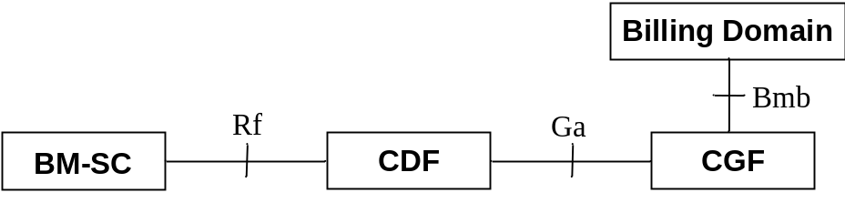
Figure 4.2: Charging architecture for MBMS offline charging

4.3 MBMS online charging architecture
Figure 4.3 depicts the MBMS online charging architecture.
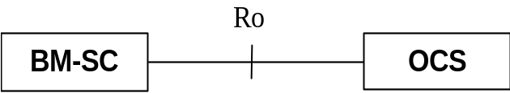
Figure 4.3: Charging architecture for MBMS online charging
For online charging, the BM-SC utilizes the Ro interface and the protocol and application towards the OCS is as specified in 3GPP TS 32.299 [50] and the present document.

5 MBMS charging principles and scenarios

5.1 MBMS charging principles

5.1.1 General principles for GPRS
A Multimedia Broadcast and Multicast Service consists of an MBMS User service, as defined in TS 22.246 [202] and TS 26.346 [203], that is delivered over one or more MBMS bearer services, as defined in TS 22.146 [201] and TS 23.246 [200].
NOTE: MBMS bearer service is referred in 3GPP TS 22.246 [202] as MBMS transport service.
The BM-SC shall collect charging information for mobile subscribers receiving services through MBMS and/or for content providers delivering content through MBMS. Transactions involving the content provider (or VASP) shall be possible.
The BM-SC collects charging related information, such as:
- Identification of the source of content.
- Type of user service (streaming, download or carousel).
- Type of bearer service used to deliver content (broadcast or multicast).
- Identification of subscribers receiving service.
- Delivery notification from individual subscribers.
NOTE: Carousel services are not considered in the present document in the current 3GPP release.
The following table shows the parties to be charged for the different MBMS bearer services used as identified by 3GPP TS 22.246 [202] and 3GPP TS 22.146 [201].
Table 5.1.1: Charging requirements for service delivery
Service Aspects | MBMS Bearer Service used
Service Aspects | Multicast (one or more) | Broadcast (one or more)
User Service (Content) | Receiving subscriber | Receiving subscriber
Bearer Service (Transport) | Content provider and/or receiving subscriber | Content provider

The user service, as shown in table 5.1.1, shall be charged either by subscription (out of scope of the present document) or as a one time event charge (e.g. key management). Charging associated with the user service may be treated independently from charging associated with the transport of the user service.
Charging for the bearer service may be based on the session information (e.g. QoS, media type, and service area) and one of the following, as described in 3GPP TS 22.146 [201]:
- Session duration (time from the MBMS Session Start procedure to MBMS Session Stop procedure as defined in 3GPP TS 23.246 [200]).
- Volume of data of a session.
- Duration of time whilst a subscriber is registered to receive a user service (or from Join to Leave).
- Volume of data transferred whilst a subscriber is registered to receive a user service (from Join to Leave).
Table 5.1.2 shows the applicability of the accounting measurements to the different bearer services used.
Table 5.1.2: Applicability of accounting measurements
Accounting measurement | Applicable to (Yes / No)
Accounting measurement | Broadcast Service | Multicast Service
Session Duration | Yes | Yes
Volume of data of a session | Yes | Yes
Duration of time whilst a subscriber is registered to receive a session | No | Yes
Volume of data transferred whilst a subscriber is registered to receive a session | No | Yes

5.1.1A General principles for EPS
The BM-SC shall collect charging information for mobile subscribers receiving services through MBMS and/or for content providers delivering content through MBMS. Transactions involving the content provider (or VASP) shall be possible.
NOTE: General principles are dependant on SA2 work in 3GPP TS 23.246 [200].
The BM-SC collects charging related information, such as:
- Identification of the source of content.
- Type of user service (streaming, download or carousel).
- Type of bearer service used to deliver content (broadcast or enhanced broadcast).
NOTE: Carousel services are not considered in the present document in the current 3GPP release.
The following table shows the parties to be charged for the different MBMS bearer services used as identified by 3GPP TS 22.246 [202] and 3GPP TS 22.146 [201].
Table 5.1.1A-1: Charging requirements for service delivery
Service Aspects | MBMS Bearer Service used
Service Aspects | Enhanced Broadcast (one or more) | Broadcast (one or more)
User Service (Content) | Receiving subscriber | Receiving subscriber
Bearer Service (Transport) | Content provider | Content provider

The user service, as shown in table 5.1.1A, shall be charged either by subscription (out of scope of the present document) or as a one time event charge (e.g. key management). Charging associated with the user service may be treated independently from charging associated with the transport of the user service.
Charging for the bearer service may be based on the session information (e.g. QoS, media type, and service area) and one of the following, as described in 3GPP TS 22.146 [201]:
- Session duration (time from the MBMS Session Start procedure to MBMS Session Stop procedure as defined in 3GPP TS 23.246 [200]).
- Volume of data of a session.
Table 5.1.1A-2 shows the applicability of the accounting measurements to the different bearer services used.
Table 5.1.1A-2: Applicability of accounting measurements
Accounting measurement | Applicable to (Yes / No)
Accounting measurement | Broadcast Service | Enhanced Broadcast Service
Session Duration | Yes | Yes
Volume of data of a session | Yes | Yes
Duration of time whilst a subscriber is registered to receive a session | No | No
Volume of data transferred whilst a subscriber is registered to receive a session | No | No

5.1.2 Triggers for generation of charging information
- Bearer service initiation/termination.
- Key management.

5.2 MBMS offline charging scenarios

5.2.1 Basic principles
As described in clause 5.1, charging may be based on events (such as key management) or based on MBMS sessions. However, as large numbers of users are expected to use services delivered using MBMS, generation of charging information should be performed in a manner that ensures the charging entities and billing domain are not overloaded.
Charging information shall be generated for subscribers and/or for content providers.
This reporting is achieved by sending Diameter Accounting Requests (ACR) [start, interim, stop and event] from the BM-SC to the CDF.
The Diameter client (BM-SC) uses ACR start, interim and stop in procedures related to both subscriber and content provider charging
In table 5.2.1.1, table 5.2.1.2 and table 5.2.1.3, the terms "configurable" implies that operators may enable or disable the generation of an ACR message by the IMS node in response to a particular trigger.
Table 5.2.1.1: Accounting Request messages for subscriber charging for GPRS
Diameter message | Trigger | Mandatory/ Configurable
ACR [Start] | Authorization of UE to MBMS Bearer Service (for multicast only) | Mandatory
ACR [Start] | Reception of first Session Start Response from any GGSN (for broadcast only) | Configurable
ACR [Interim] | Authorization of MBMS UE context activation (for multicast only) | Configurable
ACR [Interim] | Reception of first Session Start Response from any GGSN (for multicast only) | Configurable
ACR [Interim] | Reception of first Session Stop Response from any GGSN (for multicast only) | Configurable
ACR [Interim] | Expiration of AVP [Acct-Interim-Interval] | Configurable
ACR [Interim] | Reception of MBMS UE context modification | Configurable
ACR [Stop] | Reception of Leave Indication from UE (for multicast only) | Mandatory
ACR [Stop] | Reception of first Session Stop Response from any GGSN (for broadcast only) | Configurable
ACR [Stop] | Implementation dependent for termination of MBMS User Service | Configurable
ACR [Event] | Implementation dependent for MBMS User Service charging | Configurable

Table 5.2.1.2: Accounting Request messages for content provider charging for GPRS
Diameter message | Trigger | Mandatory/ Configurable
ACR [Start] | First Session Start Response from any GGSN | Mandatory
ACR [Interim] | Registration or Deregistration Request received from any GGSN | Configurable
ACR [Interim] | Deregistration Response received from any GGSN | Configurable
ACR [Interim] | Expiration of AVP [Acct-Interim-Interval] | Configurable
ACR [Stop] | First Session Stop Response from any GGSN | Mandatory

Table 5.2.1.3: Accounting Request messages for content provider charging for EPS
Diameter message | Trigger | Mandatory/ Configurable
ACR [Start] | First Session Start Response from any MBMS GW. | Mandatory
ACR [Interim] | Deregistration Response received from any MBMS GW. | Configurable
ACR [Interim] | Expiration of AVP [Acct-Interim-Interval] | Configurable
ACR [Stop] | First Session Stop Response from any MBMS GW. | Mandatory

5.2.2 Rf message flows

5.2.2.1 Broadcast Service

5.2.2.1.1 User service charging
A MBMS user service that is delivered using a broadcast bearer may be Event charged or Session charged. As there is no 3GPP specified signalling for a UE to activate or deactivate the broadcast service, it is MBMS user service dependent (e.g. key management) when the Accounting Request is triggered. The Event based and Session based offline charging flows are as defined in 3GPP TS 32.299 [50].

5.2.2.1.2 Session Start for GPRS
Where charging for the content provider is applied for GPRS, the following procedure applies as shown in figure 5.2.2.1.2.
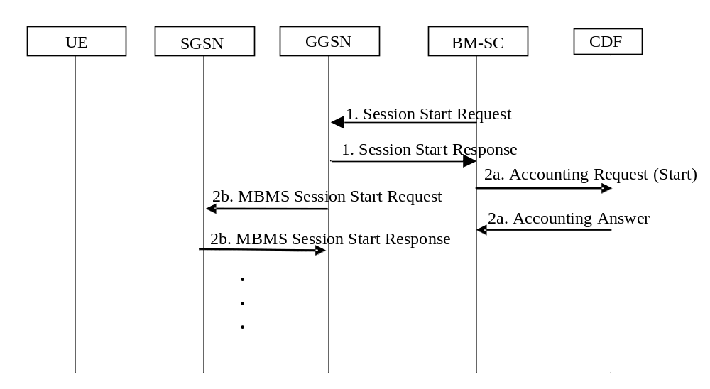
Figure 5.2.2.1.2: Rf interaction during Broadcast Session Start Procedure for a broadcast bearer
1) The BM-SC performs the MBMS Session Start procedure as described in 3GPP TS 23.246 [200].
2a) On receiving the first MBMS Session Start Response from any GGSN, the BM-SC sends an Accounting Request.
2b) The remainder of the MBMS Session Start procedure may occur in parallel with the Accounting Request procedure in 2a.
The full details of the MBMS Session Start procedure for the broadcast bearer are described in 3GPP TS 23.246 [200].

5.2.2.1.2A Session Start for EPS
The following procedure in figure 5.2.2.1.2A shows the charging interaction for EPS during the MBMS Session Start procedure for a broadcast bearer.
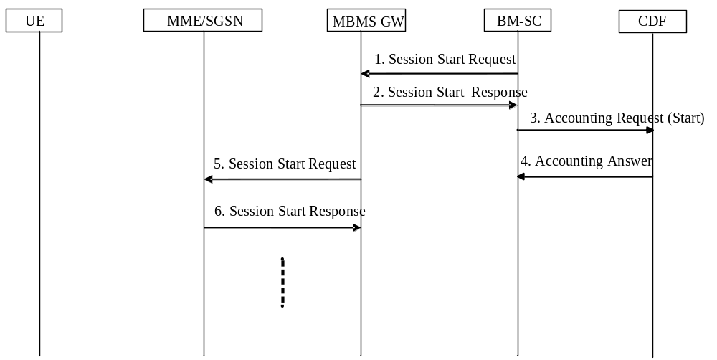
Figure 5.2.2.1.2A: Rf interaction during Broadcast Session Start Procedure for a broadcast bearer
1-2) The BM-SC performs the MBMS Session Start procedure as described in TS 23.246 [200].
3-4) On receiving the first MBMS Session Start Response from any MBMS GW, the BM-SC sends an Accounting Request.
5-6) The remainder of the MBMS Session Start procedure may occur in parallel with the Accounting Request procedure in 3-4).
The full details of the MBMS Session Start procedure for the broadcast bearer are described in TS 23.246 [200].

5.2.2.1.2B Void

5.2.2.1.3 Session Stop for GPRS
The following procedure in figure 5.2.2.1.3 shows the charging interaction for GPRS during the MBMS Session Stop procedure for a broadcast bearer.
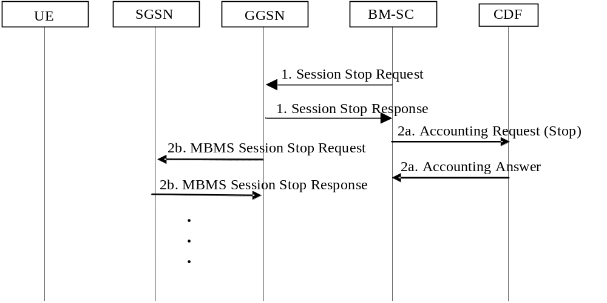
Figure 5.2.2.1.3: Rf interaction during MBMS Session Stop procedure for a broadcast bearer
1) The BM-SC performs the MBMS Session Stop procedure as described in 3GPP TS 23.246 [200].
2a) On receiving a Session Stop Response from any GGSN, the BM-SC sends a Accounting Request.
2b) The remainder of the MBMS Session Stop procedure occurs in parallel with the Accounting Request procedure in 2a.
The full details of the MBMS Session Stop procedure for the broadcast bearer are described in 3GPP TS 23.246 [200].

5.2.2.1.3A Session Stop for E-UTRAN
The following procedure in figure 5.2.2.1.3A shows the charging interaction for EPS during the MBMS Session Stop procedure for a broadcast bearer.
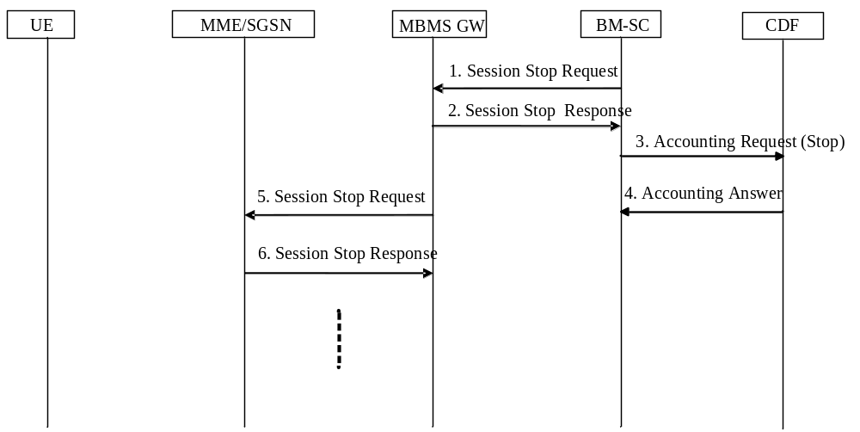
Figure 5.2.2.1.3A: Rf interaction during MBMS Session Stop procedure for a broadcast bearer
1-2) The BM-SC performs the MBMS Session Stop procedure as described in TS 23.246 [200].
3-4) On receiving the first MBMS Session Stop Response from any MBMS GW, the BM-SC sends an Accounting Request.
5-6) The remainder of the MBMS Session Stop procedure may occur in parallel with the Accounting Request procedure in 3-4).
The full details of the MBMS Session Stop procedure for the broadcast bearer are described in TS 23.246 [200].

5.2.2.1.3B Void

5.2.2.1.4 BM-SC initiated Registration and De-Registration
BM-SC initiated Registration and De-Registration are handled through O&M towards the GGSNs (and subsequent nodes) and therefore Rf interactions (Accounting Request (Start) and Accounting Request (Stop) respectively) may be triggered when the Registration and De-Registration is triggered through O&M. These Rf interactions should only occur for sessions that have already started.

5.2.2.1.5 Session Update for EPS with E-UTRAN and UTRAN
The following procedure in figure 5.2.2.1.5 shows the charging interaction for EPS during the MBMS Session Update procedure for a broadcast bearer
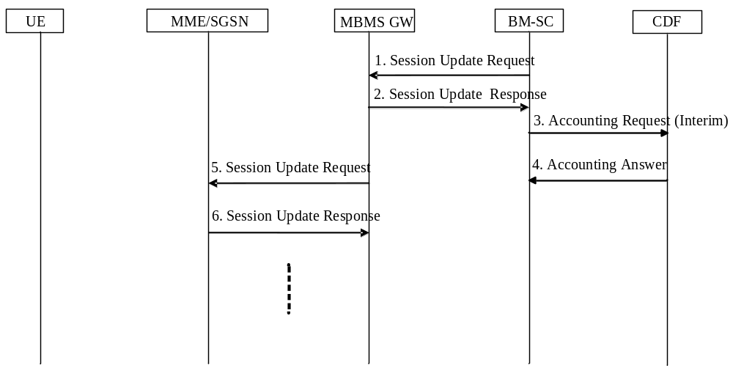
Figure 5.2.2.1.5: Rf interaction during Broadcast Session Update Procedure for a broadcast bearer
1-2) The BM-SC performs the MBMS Session Update procedure as described in TS 23.246 [200].
3-4) On receiving the first MBMS Session Update Response from any MBMS GW, the BM-SC sends an Accounting Request.
5-6) The remainder of the MBMS Session Update procedure may occur in parallel with the Accounting Request procedure in 3-4).
The full details of the MBMS Session Update procedure for the broadcast bearer are described in TS 23.246 [200].

5.2.2.2 Multicast Service

5.2.2.2.1 Session Start
The following procedure in figure 5.2.2.2.1 shows the charging interaction during the MBMS Session Start procedure for a multicast bearer.
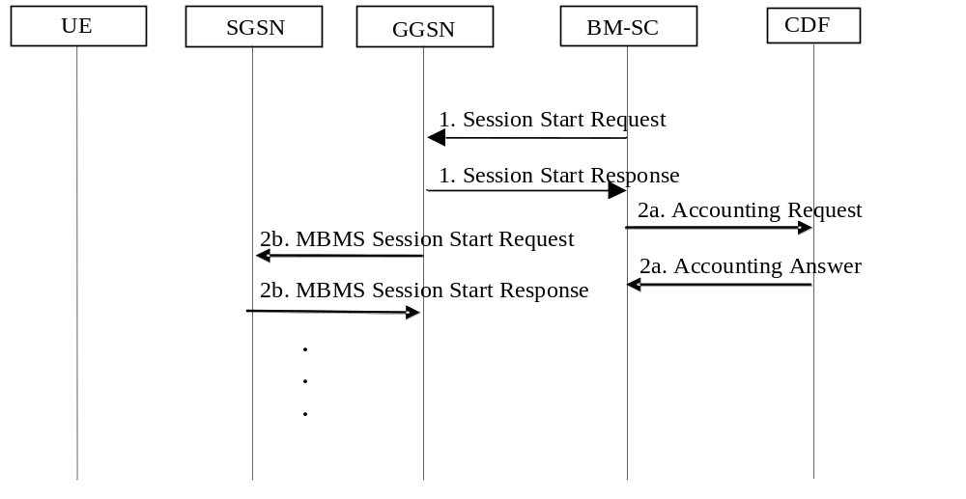
Figure 5.2.2.2.1: Rf interaction during MBMS Session Start procedure for a multicast bearer
1) The BM-SC performs the MBMS Session Start procedure as described in 3GPP TS 23.246 [200].
2a) On receiving the first Session Start Response from any GGSN, the BM-SC sends an Accounting Request. The accounting request may be for subscriber and/or content provider charging. For subscriber charging, the Accounting Request shall be "Interim". For content provider charging, the Accounting Request shall be "Start". It shall be possible to send one Accounting Request message for multiple subscribers of the same multicast service, but the procedure in the BM-SC to group subscribers is implementation dependent.
2b) The remainder of the MBMS Session Start procedure occurs in parallel with the Accounting Request procedure in 2a.
The full details of the MBMS Session Start procedure for the multicast bearer are described in 3GPP TS 23.246 [200].

5.2.2.2.2 Session Stop
The following procedure in figure 5.2.2.2.2 shows the charging interaction during the MBMS Session Stop procedure for a multicast bearer.
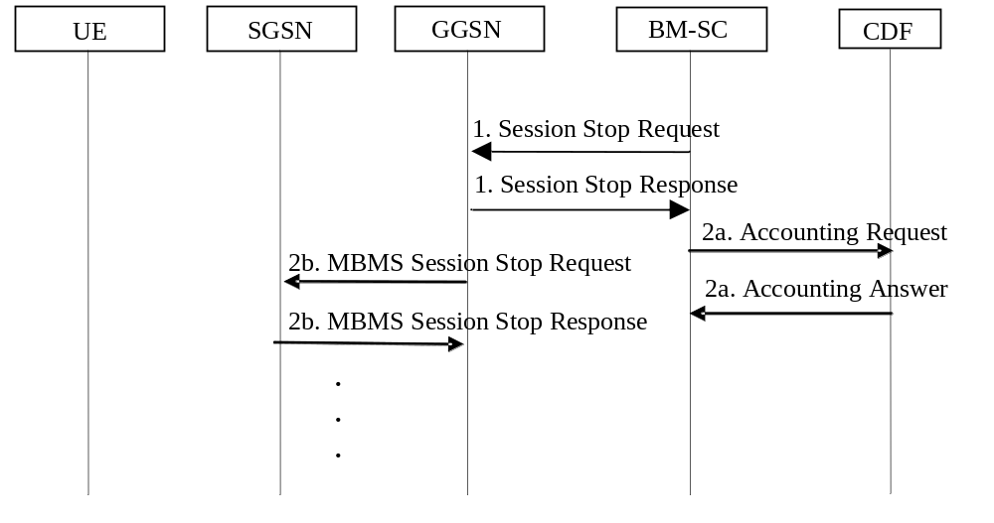
Figure 5.2.2.2.2: Rf interaction during MBMS Session Stop procedure for a multicast bearer
1) The BM-SC performs the MBMS Session Stop procedure as described in 3GPP TS 23.246 [200].
2a) On receiving the first Session Stop Response from any GGSN, the BM-SC sends a Accounting Request.
For subscriber charging, the Accounting Request shall be "Interim" and it shall be possible to send one Accounting Request message for multiple or all subscribers of the same multicast service, that are still active, and is implementation and service dependent.
For content provider charging, the Accounting Request shall be "Stop".
2b) The remainder of the MBMS Session Stop procedure occurs in parallel with the Accounting Request procedure in 2a.
The full details of the Session Stop procedure for the multicast bearer are described in 3GPP TS 23.246 [200].

5.2.2.2.3 BM-SC initiated MBMS De-registration
The following procedure in figure 5.2.2.2.3 shows the charging interaction during the BM-SC initiated MBMS De-registration procedure for a multicast bearer for an already started session.
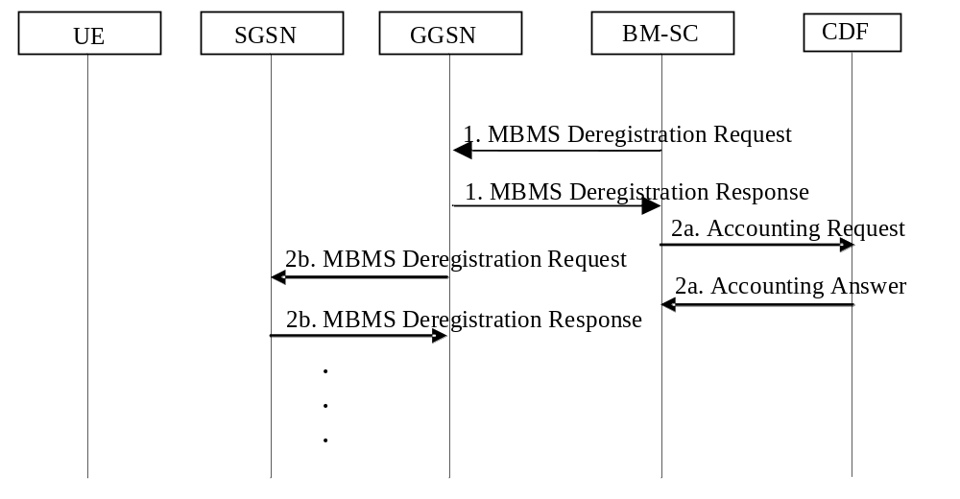
Figure 5.2.2.2.3: Rf interaction during BM-SC initiated MBMS Deregistration procedure
for a multicast bearer
1) The BM-SC performs the MBMS Deregistration procedure as described in 3GPP TS 23.246 [200].
The BM-SC sends a De-Registration Request message to all GGSNs contained in the "list of downstream nodes" parameter of the corresponding MBMS Bearer Context to indicate the session is terminated.
2a) On receiving an MBMS Deregistration Response from the GGSN, the BM-SC sends a Accounting Request "Stop".
2b) The remainder of the MBMS Deregistration procedure occurs in parallel with the Accounting Request procedure in 2a.
The full details of the MBMS Deregistration procedure for the multicast bearer are described in 3GPP TS 23.246 [200].

5.2.2.2.4 UE Activation
The following procedure in figure 5.2.2.2.4 should apply to subscriber's that activate the multicast service.
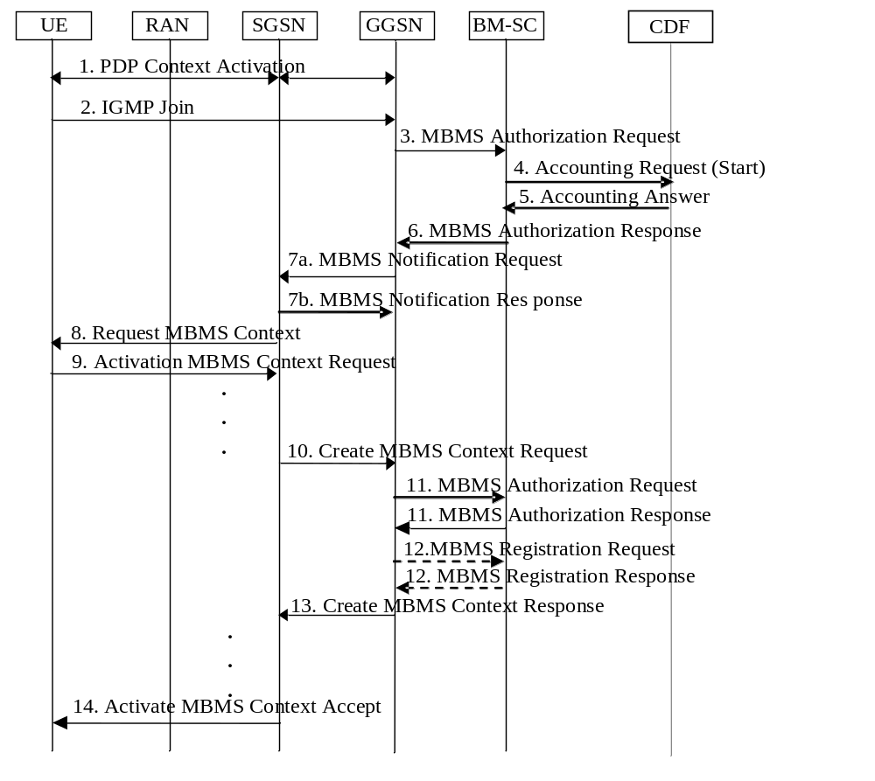
Figure 5.2.2.2.4: Rf interaction during MBMS Multicast Service Activation procedure
for a multicast bearer
Full details of the activation procedure are described in the MBMS Multicast Service Activation procedure in 3GPP TS 23.246 [200].

5.2.2.2.5 UE Deactivation
The following procedure in figure 5.2.2.2.5 should only apply to subscriber's that deactivate the multi-cast service before the session has stopped, i.e. before the MBMS Session Stop procedure is invoked.
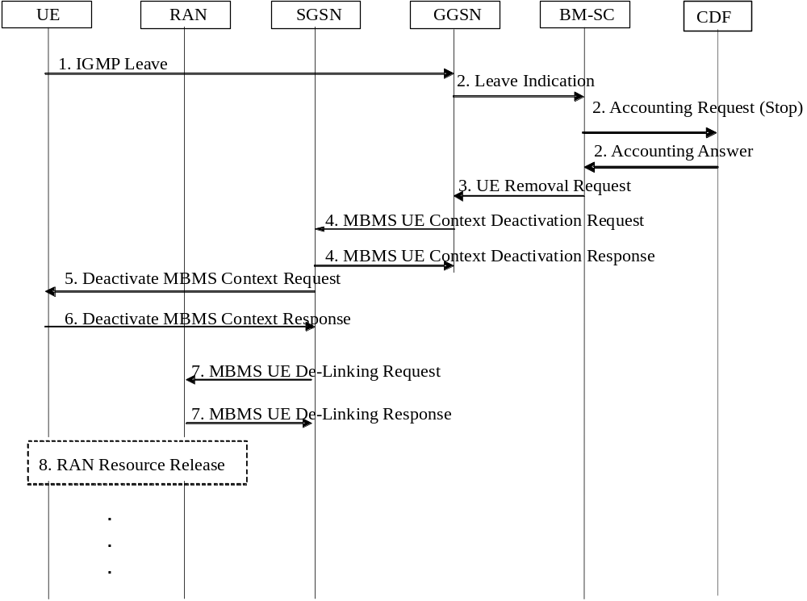
Figure 5.2.2.2.5: Rf interaction during MBMS Multicast Service Deactivation procedure
for a multicast bearer
Full details of the deactivation procedure are described in the MBMS Multicast Service Deactivation procedure in 3GPP TS 23.246 [200].

5.2.3 CDR generation

5.2.3.1 CDRs related to MBMS subscribers

5.2.3.1.1 Triggers for S-BMSC-CDR charging information collection
A S-BMSC-CDR is used to collect charging information related to the MBMS Bearer Service information for a UE/MS in the BM-SC. A CDR is generated for each MBMS bearer service used and for each subscriber using the MBMS Bearer Service.
A S-BMSC-CDR shall be opened at UE activation as triggered by an ACR (Start). The volume for the MBMS bearer context is counted in downlink direction.
The subsequent clauses identify in detail the conditions for adding information to, and closing the BMSC-CDR for generation towards the CGF.

5.2.3.1.2 Triggers for S-BMSC-CDR Charging Information Addition
A new container shall be added to the S-BMSC-CDR on encountering some trigger conditions. Table 5.2.3.1.2 identifies which conditions are supported to permit addition of a new container to the S-BMSC-CDR. The start time of the new container shall indicate the time, whichever is later, at which the first Session Start Response was received, MBMS UE context activation, or the last partial CDR was closed.
Table 5.2.3.1.2: Triggers for S-BMSC-CDR addition
Closure Conditions | Description/Behaviour
Tariff Time Change | On reaching the Tariff Time Change a set of "List of Traffic Data Volumes" containers, i.e. all active traffic data flow containers, shall be added to the CDR.
Session Start | A Traffic Data Volume container may be added when an MBMS Session Start is performed
Session Stop | A Traffic Data Volume container may be added when an MBMS Session Stop is performed.
MBMS UE context modification | A Traffic Data Volume container may be added when an MBMS UE context modification is received by the BM-SC. See note 1.
CDR Closure | All active "List of Traffic Data Volumes" containers shall be added to the eG-CDR.
NOTE 1: One trigger for modification of MBMS UE context is as a result of inter-system (RAT) change and there is no reliable mechanism to report the change at the actual time of change. This is due to the UE remaining in IDLE mode from the core network perspective.

NOTE 2: MBMS charging is based on the volume of downlink data. Therefore the “List of Traffic Data Volumes” shall not count data volumes in uplink direction.

NOTE: One trigger for modification of MBMS UE context is as a result of inter-system (RAT) change and there is no reliable mechanism to report the change at the actual time of change. This is due to the UE remaining in IDLE mode from the core network perspective.

5.2.3.1.3 Triggers for S-BMSC-CDR closure
The S-BMSC-CDR shall be closed on encountering some trigger conditions. Table 5.2.3.1.3 identifies which conditions are supported to permit closure of the S-BMSC-CDR.
Table 5.2.3.1.3: Triggers for S-BMSC-CDR closure
Closure Conditions | Description/Behaviour
Service Deactivation | Deactivation of the MBMS service in the BM-SC shall result in the CDR being closed. The trigger condition covers:  - UE initiated deactivation;  - termination of the MBMS User Service  - any abnormal release.
ACR (Stop) | On reception of ACR (Stop), a CDR is closed.
Partial Record Reason | O&M reasons permit the closure of the CDR for internal reasons. The trigger condition covers:  - data volume limit;  - time (duration) limit;  - maximum number of charging condition changes;  - management intervention.

The Partial Record generation trigger thresholds are those associated with the Charging Characteristics. The Partial Record generation trigger thresholds are configuration parameters defined per charging characteristics profile by the operator through O&M means.

5.2.3.2 CDRs related to content provider

5.2.3.2.1 Triggers for BMSC-CDR charging information collection
A C-BMSC-CDR is used to collect charging information related to the MBMS Bearer Service information for a content provider to the BM-SC. A C-BMSC-CDR is generated for each MBMS Bearer Service.
A C-BMSC-CDR shall be opened at MBMS Session Start as triggered by an ACR (Start). The volume for the MBMS bearer context is counted in downlink direction. Not all of the charging information to be collected is static, and may be dependent on dynamic (de-)registration of packet-switched nodes to the MBMS bearer context.
The subsequent clauses identify in detail the conditions for adding information to, and closing the C-BMSC-CDR for passing towards the CGF.

5.2.3.2.2 Triggers for C-BMSC-CDR Charging Information Addition
A new container shall be added to the C-BMSC-CDR on encountering some trigger conditions. Table 5.2.3.2.2 identifies which conditions are supported to permit addition of a new container to the C-BMSC-CDR.
Table 5.2.3.2.2: Triggers for C-BMSC-CDR addition
Closure Conditions | Description/Behaviour
Tariff Time Change | On reaching the Tariff Time Change a set of "List of Traffic Data Volumes" containers, i.e. all active service data flow containers, shall be added to the CDR.
CDR Closure | All active "List of Traffic Data Volumes" containers shall be added to the eG-CDR.
NOTE: MBMS charging is based on the volume of downlink data. Therefore the “List of Traffic Data Volumes” shall not count data volumes in uplink direction.

5.2.3.2.3 Triggers for C-BMSC-CDR closure
The C-BMSC-CDR shall be closed on encountering some trigger conditions. Table 5.2.3.2.3 identifies which conditions are supported to permit closure of the C-BMSC-CDR.
Table 5.2.3.2.3: Triggers for C-BMSC-CDR closure
Closure Conditions | Description/Behaviour
Service Deactivation | Deactivation of the MBMS service in the BM-SC shall result in the CDR being closed. The trigger condition covers:  - MBMS Session Stop;  - termination of the MBMS User Service  - any abnormal release.
ACR (Stop) | On reception of an ACR (Stop), the CDR shall be closed.
Partial Record Reason | O&M reasons permit the closure of the CDR for internal reasons. The trigger condition covers:  - data volume limit;  - time (duration) limit;  - change in list of downstream nodes;  - management intervention;  - MBMS service area;  - access indicator.

The Partial Record generation trigger thresholds are configuration parameters defined per charging characteristics profile by the operator through O&M means.

5.2.4 Ga record transfer flows
For further details on the Ga protocol application refer to 3GPP TS 32.295 [54].

5.2.5 B_{mb} CDR file transfer
The CGF transfers the CDR files to the BD as described in 3GPP TS 32.297 [52]. For further details on the Bmb protocol application refer to 3GPP TS 32.297 [52].

5.3 MBMS online charging scenarios

5.3.1 Basic principles
MBMS online charging uses the credit control application as specified in 3GPP TS 32.299 [50] and the present document.
Online charging of content providers is not supported in this release of the present document.
The type of online interaction used is dependent on the user service type, bearer type and whether delivery notification is required. Table 5.3.1 shows this dependency
Table 5.3.1: Online interaction dependency on MBMS service parameters
User Service Type | Bearer Service Type | Delivery Notification | Online Interaction
Key Management | N/A | N/A | IEC
Streaming | Broadcast | N/A | Operator Configurable
Streaming | Multicast | N/A | SCUR
Download | Broadcast | Required | Operator Configurable
Download | Multicast | Required | Operator Configurable
Download | Broadcast | Not required | Operator Configurable
Download | Multicast | Not required | Operator Configurable
NOTE: Operator configurable options imply that IEC, SCUR and ECUR should be supported

It is not possible to perform charging transactions in a load efficient manner as in offline charging (see clause 5.2). Therefore, one online charging interaction is necessary for each user.

5.3.2 Ro message flows

5.3.2.1 Broadcast Service

5.3.2.1.1 User service charging
A MBMS user service that is delivered using a broadcast bearer may be Event charged or Session charged. As there is no 3GPP specified signalling for a UE to activate or deactivate the broadcast service, it is MBMS user service dependent (e.g. key management) when the Accounting Request is triggered. The Event based or Session based online charging flows are as defined in 3GPP TS 32.299 [50].

5.3.2.1.2 Session Start
As online charging does not apply to content provider, this scenario is not applicable.

5.3.2.1.3 Session Stop
As online charging does not apply to content provider, this scenario is not applicable.

5.3.2.1.4 BM-SC initiated Registration and De-Registration
As online charging does not apply to content provider, this scenario is not applicable.

5.3.2.2 Multicast Service

5.3.2.2.1 Session Start
The following procedure in figure 5.3.2.2.1 shows the charging interaction during the MBMS Session Start procedure for a multicast bearer.
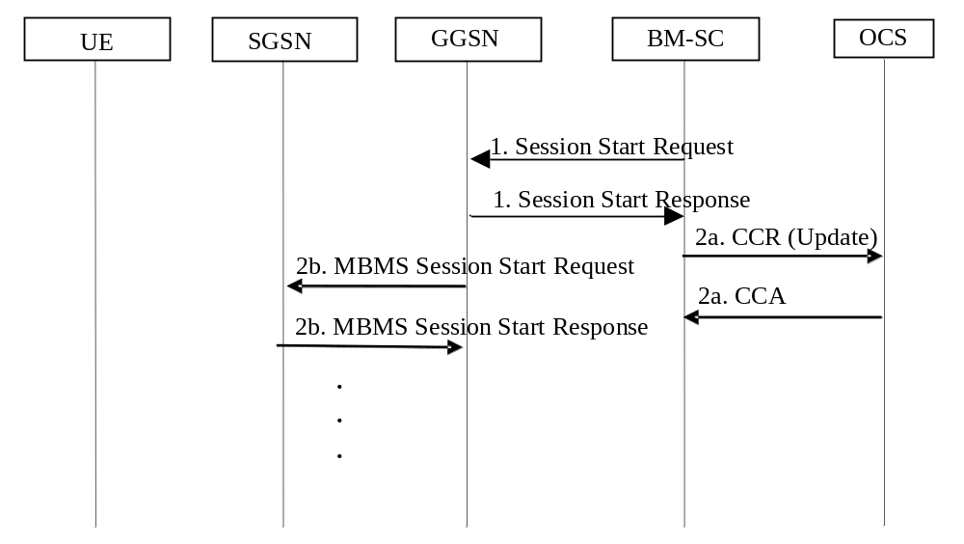
Figure 5.3.2.2.1: Ro interaction during MBMS Session Start procedure for a multicast bearer
1) The BM-SC performs the MBMS Session Start procedure as described in 3GPP TS 23.246 [200]
2a) On receiving the first Session Start Response from any GGSN, the BM-SC sends a Credit Control Request for each subscriber that has joined the service.
2b) The remainder of the MBMS Session Start procedure occurs in parallel with the Credit Control Request procedure in 2a.
The full details of the MBMS Session Start procedure for the multicast bearer are described in 3GPP TS 23.246 [200].

5.3.2.2.2 Session Stop
The following procedure in figure 5.3.2.2.2 shows the charging interaction during the MBMS Session Stop procedure for a multicast bearer.
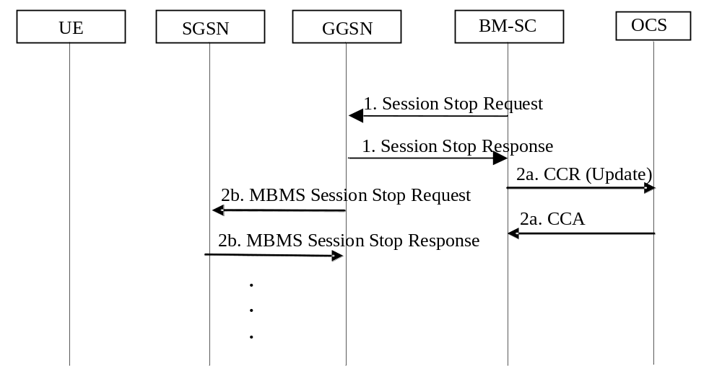
Figure 5.3.2.2.2: Ro interaction during MBMS Session Stop procedure for a multicast bearer
1) The BM-SC performs the MBMS Session Stop procedure as described in 3GPP TS 23.246 [200]
2a) On receiving the first Session Stop Response from any GGSN, the BM-SC sends a Credit Control Request for each subscriber that is still joined to the service.
2b) The remainder of the MBMS Session Stop procedure occurs in parallel with the Credit Control Request procedure in 2a.
The full details of the Session Stop procedure for the multicast bearer are described in 3GPP TS 23.246 [200].

5.3.2.2.3 BM-SC initiated MBMS De-registration
The procedure in figure 5.3.2.2.3 shows the charging interaction during the BM-SC initiated MBMS De-registration procedure for a multicast bearer for an already started session.
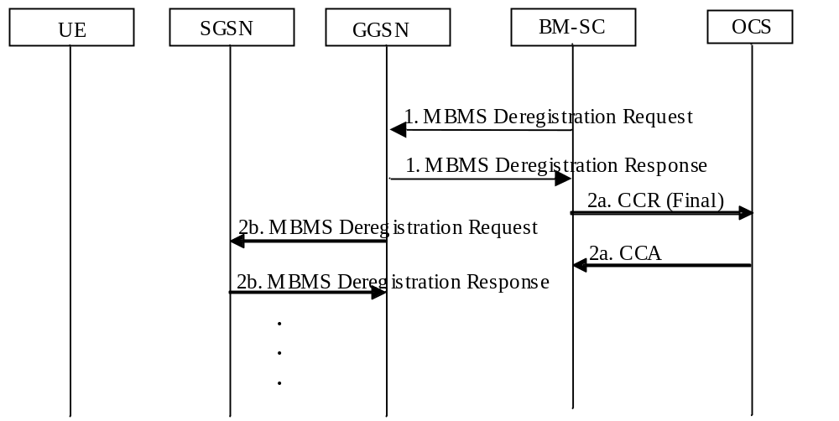
Figure 5.3.2.2.3: Ro interaction during BM-SC initiated MBMS Deregistration procedure
for a multicast bearer
1) The BM-SC performs the MBMS Deregistration procedure as described in 3GPP TS 23.246 [200].
The BM-SC sends a De-Registration Request message to all GGSNs contained in the "list of downstream nodes" parameter of the corresponding MBMS Bearer Context to indicate the session is terminated.
2a) On receiving an MBMS Deregistration Response from the GGSN, the BM-SC sends a Credit Control Request "Final" for each subscriber that has joined the service.
2b) The remainder of the MBMS Deregistration procedure occurs in parallel with the Accounting Request procedure in 2a.
The full details of the MBMS Deregistration procedure for the multicast bearer are described in 3GPP TS 23.246 [200].

5.3.2.2.4 UE Activation
The following procedure in figure 5.3.2.2.4 applies to subscribers that activate the multicast service.
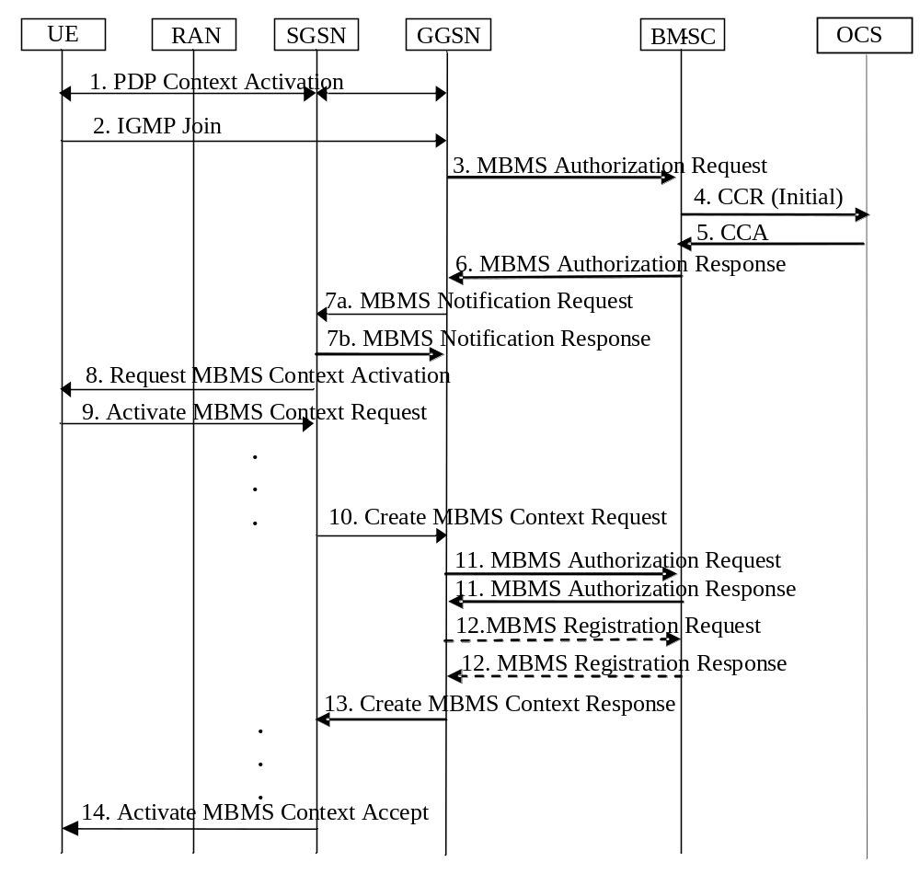
Figure 5.3.2.2.4: Ro interaction during MBMS Multicast Service Activation procedure
for a multicast bearer
Full details of the activation procedure are described in the MBMS Multicast Service Activation procedure in 3GPP TS 23.246 [200].

5.3.2.2.5 UE Deactivation
The following procedure in figure 5.3.2.2.5 applies to subscribers that deregisters from the multi-cast service before the session has stopped, i.e. before the MBMS Session Stop procedure is invoked. The following procedure is optionally applied, if the deactivation occurs after the MBMS Session Stop procedure, depending on the charging model applied.
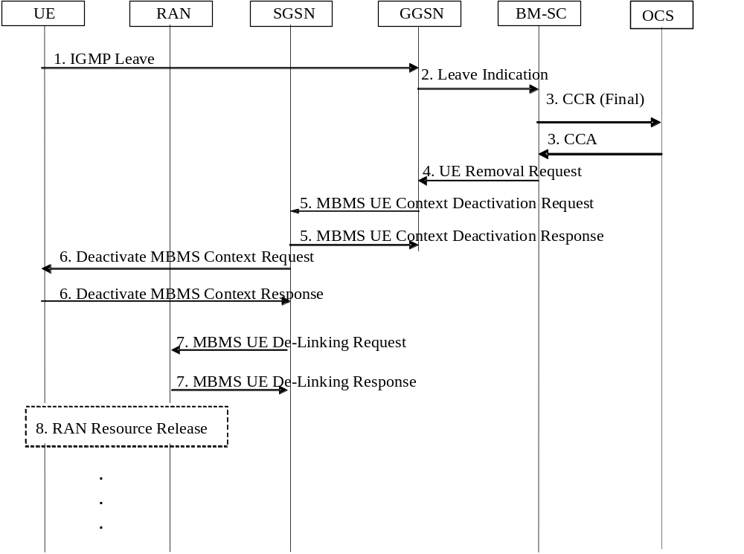
Figure 5.3.2.2.5: Ro interaction during MBMS Multicast Service Deactivation procedure
for a multicast bearer
Full details of the deactivation procedure are described in the MBMS Multicast Service Deactivation procedure in 3GPP TS 23.246 [200].

5.3.3 Credit Control related

5.3.3.1 Triggers for stopping for an MBMS service Credit Control session
In addition to message flows in clause 5.3.2, a CCR [Terminate] is sent to OCS when:
- Session termination is indicated by the OCS (e.g. Credit Limit Reached);
- Abort-Session-Request is received from the OCS, this also results in the deactivation of the MBMS UE Context (from step 4 of clause 5.3.2.2.5), if one exists for the session being terminated.

5.3.3.2 Triggers for providing interim information for a MBMS service Credit Control session
In addition to the message flows in clause 5.3.2, a CCR [Update] is sent to OCS when:
- Granted quota runs out;
- Validity time for granted quota expires;
- Update is requested by the OCS;
- Change of charging conditions occur and according re-authorisation trigger re-authorisation is needed;
- Management intervention.

6 Definition of charging information

6.1 Data description for MBMS offline charging

6.1.1 Rf message contents

6.1.1.1 Summary of Offline Charging Message Formats
The BM-SC generates accounting information that can be transferred to the CDF. For this purpose, the MBMS Accounting application employs the Accounting-Request (ACR) and Accounting-Answer (ACA) messages from the Diameter base protocol. The request can be of type start, stop, interim and event. The accounting request message includes all charging information and the answer is just an acknowledgement of the request message. Detailed information about the Diameter offline charging application is described in 3GPP TS 32.299 [50].
The following clauses describe the different fields used in the accounting messages.
Table 6.1.1.1 describes the use of these messages for offline charging.
Table 6.1.1.1: Offline Charging Messages Reference Table
Command-Name | Source | Destination | Abbreviation
Accounting-Request | BM-SC | CDF | ACR
Accounting-Answer | CDF | BM-SC | ACA

6.1.1.2 Structure for the Accounting Message Formats

6.1.1.2.1 Accounting-Request Message
Table 6.1.1.2.1 illustrates the basic structure of a Diameter ACR message as used for MBMS offline charging.
Table 6.1.1.2.1: Accounting-Request (ACR) Message Contents for Offline Charging
Field | Category | Description
Session-Id | M | Used as described in TS 32.299 [50].
Origin-Host | M | Used as described in TS 32.299 [50].
Origin-Realm | M | Used as described in TS 32.299 [50].
Destination-Realm | M | Used as described in TS 32.299 [50].
Accounting-Record-Type | M | Used as described in TS 32.299 [50].
Accounting-Record-Number | M | Used as described in TS 32.299 [50].
Acct-Application-Id | M | Used as described in TS 32.299 [50].
User-Name | OC | Used as described in TS 32.299 [50].
Acct-Session-Id | - | Not used in 3GPP.
Acct-Interim-Interval | OC | Used as described in TS 32.299 [50].
Origin-State-Id | OC | Used as described in TS 32.299 [50].
Event-Timestamp | OC | Used as described in TS 32.299 [50].
Proxy-Info | - | Not used in 3GPP.
Route-Record | - | Not used in 3GPP.
Service-Context-Id | OM | Used as described in TS 32.299 [50]
Service-Information | OM | Described in TS 32.299 [50]
Subscription Id | OM | Used as described in TS 32.299 [50].  As a minimum the IMSI and the MSISDN have to be included for subscriber charging.
PS-Information | OC | Described in TS 32.251 [11]
IMS-Information | OC | Described in TS 32.260 [20]
MBMS-Information | OM | Described in clause 6.3
NOTE: For structured fields only the "field" is listed in this table.
Detailed description of the fields is provided according to "Description" column.

6.1.1.2.2 Accounting-Answer Message
Table 6.1.1.2.2 illustrates the basic structure of a Diameter ACA message as used for MBMS charging. This message is always used by the CDF as specified below, regardless of the BM-SC it is received from and the ACR record type that is being replied to.
Table 6.1.1.2.2: Accounting-Answer (ACA) Message Contents for Offline Charging
Field | Category | Description
Session-Id | M | Used as described in TS 32.299 [50].
Result-Code | M | Used as described in TS 32.299 [50].
Origin-Host | M | Used as described in TS 32.299 [50].
Origin-Realm | M | Used as described in TS 32.299 [50].
Accounting-Record-Type | M | Used as described in TS 32.299 [50].
Accounting-Record-Number | M | Used as described in TS 32.299 [50].
Acct-Application-Id | M | Used as described in TS 32.299 [50].
User-Name | OC | Used as described in TS 32.299 [50].
Acct-Session-Id | - | Not used in 3GPP.
Acct-Interim-Interval | OC | Used as described in TS 32.299 [50].
Origin-State-Id | OC | Used as described in TS 32.299 [50].
Event-Timestamp | OC | Used as described in TS 32.299 [50].
Proxy-Info | - | Not used in 3GPP.
Extension | - | Not used in 3GPP.

6.1.2 Ga message contents

6.1.3 CDR description on the B_{mb} interface

6.1.3.1 CDR description for subscriber charging
Table 6.1.3.1: Subscriber BM-SC data (S-BMSC-CDR)
Field | Category | Description
Record Type | M | S-BM-SC record.
Served IMSI | M | IMSI of the served party. This may be obtained from the Subscription Id field, identified by a type of IMSI, of the Accounting Request message.
GGSN Address used | C | The control plane IP address of the GGSN used for MBMS UE context activation. Present only for multicast.
Access Point Name Network Identifier | OC | The logical name of the connected access point to the external packet data network (network identifier part of APN). Present only for multicast
Served PDP Address | OM | Represents the IP Multicast address associated with the MBMS bearer context.
List of Traffic Data Volumes | OM | A list of changes in charging conditions (including MBMS UE context modifications) for this MBMS bearer service, each change is time stamped.  Charging conditions are used to categorize traffic volumes, such as per tariff period. Initial and subsequently changed QoS and corresponding data volumes are also listed. See note below.
Record Opening Time | M | Time stamp when UE activation occurs or record opening time on subsequent partial records.
Duration | M | Duration of this record.
Cause for Record Closing | M | The reason for the release of record.
Diagnostics | OM | A more detailed reason for the release of the connection.
Record Sequence Number | C | Partial record sequence number, only present in case of partial records.
Node ID | OM | Name of the recording entity.
Record Extensions | OC | A set of network operator/manufacturer specific extensions to the record. Conditioned upon the existence of an extension.
Local Record Sequence Number | OM | Consecutive record number created by this node.  The number is allocated sequentially including all CDR types.
Served MSISDN | OM | The primary MSISDN of the subscriber. This may be obtained from the Subscription Id field, identified by a type of E.164, of the Accounting Request message.
Bearer Service Description | O_{C} | Holds the Session portion of the SDP data exchanged between the BMSC and UE during the notification phased
MBMS-Information | OM | A set of fields hold the MBMS specific parameters.  The details are defined in clause 6.3.1.2.
Service Context Id | O_{M} | Holds the context information to which the CDR belongs.
NOTE: MBMS charging is based on the volume of downlink data. Therefore the “List of Traffic Data Volumes” shall not count data volumes in uplink direction.

6.1.3.2 CDR description for content provider charging
Table 6.1.3.2: Content Provider BM-SC data (C-BMSC-CDR)
Field | Category | Description
Record Type | M | C-BM-SC record.
Content Provider Id | M | Identity of the content provider. This may be obtained from the Subscription ID field of the Accounting Request message.
List of Downstream Nodes | M | A list of the control plane IP address of the GGSN/MBMS GWs used by the MBMS Bearer Service.
Access Point Name Network Identifier | OC | The logical name of the connected access point to the external packet data network (network identifier part of APN). Present only for multicast
PDP/PDN Type | OM | This field indicates PDN type (i.e IPv4 or IPv6).
Served PDP/PDN Address | OM | Represents the IP Multicast address used to transmit the MBMS user service, i.e. IPv4 or IPv6, if available.
List of Traffic Data Volumes | OM | A list of changes in charging conditions (including MBMS UE context modifications) for this MBMS bearer service, each change is time stamped.  Charging conditions are used to categorize traffic volumes, such as per tariff period. Initial and subsequently changed QoS and corresponding data volumes are also listed. See note below.
Record Opening Time | M | Time stamp when MBMS Bearer Context is activated (i.e. MBMS Session Start) or record opening time on subsequent partial records.
Duration | M | Duration of this record.
Cause for Record Closing | M | The reason for the release of record.
Diagnostics | OM | A more detailed reason for the release of the connection.
Record Sequence Number | C | Partial record sequence number, only present in case of partial records.
Node ID | OM | Name of the recording entity.
Record Extensions | OC | A set of network operator/manufacturer specific extensions to the record. Conditioned upon the existence of an extension.
Local Record Sequence Number | OM | Consecutive record number created by this node.  The number is allocated sequentially including all CDR types.
Recipient Address List | OC | The address(es) of the recipients registered to receive the bearer service.
Bearer Service Description | O_{C} | Holds the Session portion of the SDP data exchanged between the BMSC and UE during the notification phased, see IMS-Information in table 6.3.1.1.
MBMS-Information | OM | A set of fields hold the MBMS specific parameters.  The details are defined in clause 6.3.1.2.
Service Context Id | O_{M} | Holds the context information to which the CDR belongs.
NOTE: MBMS charging is based on the volume of downlink data. Therefore the “List of Traffic Data Volumes” shall not count data volumes in uplink direction.

6.2 Data description for MBMS online charging

6.2.1 Ro message contents

6.2.1.1 Summary of Message Formats
MBMS Online Charging use Credit-Control-Request (CCR) and Credit-Control-Answer (CCA) messages defined in 3GPP TS 32.299 [50]. The CCR triggers the rating of the MBMS service and reserves units on the user's account. The CCA is a response including any reserved units or an error code if the user is out of credit. Detailed information about the diameter online charging application is described in 3GPP TS 32.299 [50].
The CCR for the "intermediate interrogation" and "final interrogation" reports the actual number of "units" that were used, from what was previously reserved. This determines the actual amount debited from the subscriber's account.
The following clauses describe the different fields used in the credit control messages.
Table 6.2.1.1 describes the use of these messages for online charging.
Table 6.2.1.1: Online Charging Messages Reference Table
Command-Name | Source | Destination | Abbreviation
Credit-Control-Request | BM-SC | OCS | CCR
Credit-Control-Answer | OCS | BM-SC | CCA

6.2.1.2 Structure for the Credit Control Message Formats

6.2.1.2.1 Credit-Control-Request Message
Table 6.2.1.2.1 illustrates the basic structure of a Diameter CCR message from the BM-SC as used for MBMS online charging.
Table 6.2.1.2.1: Credit-Control-Request (CCR) Message Contents
Field | Category | Description
Session-Id | M | Used as described in TS 32.299 [50].
Origin-Host | M | Used as described in TS 32.299 [50].
Origin-Realm | M | Used as described in TS 32.299 [50].
Destination-Realm | M | Used as described in TS 32.299 [50].
Auth-Application-Id | M | Used as described in TS 32.299 [50].
Service-Context-Id | M | Used as described in TS 32.299 [50].
CC-Request-Type | M | Used as described in TS 32.299 [50].
CC-Request-Number | M | Used as described in TS 32.299 [50].
Destination-Host | OC | Used as described in TS 32.299 [50].
User-Name | OC | Used as described in TS 32.299 [50].
Origin-State-Id | OC | Used as described in TS 32.299 [50].
Event-Timestamp | OC | Used as described in TS 32.299 [50].
Subscription-Id | OC | Used as described in TS 32.299 [50].  As a minimum the IMSI and the MSISDN have to be included.
Service-Identifier | OC | Used as described in TS 32.299 [50].
Termination-Cause | OC | Used as described in TS 32.299 [50].
Requested-Service-Unit | - | Not used in MBMS charging.
Requested-Action | OC | Used as described in TS 32.299 [50].
Multiple-Services-Indicator | OM | Used as described in TS 32.299 [50].
Multiple-Services-Credit Control | OC | Used as described in TS 32.299 [50].
User–Equipment-Info | OC | Used as described in TS 32.299 [50].
Service-Information | OM | Defined in TS 32.299 [50]
PS-Information | OC | Used as described in TS 32.251 [11]
IMS-Information | Oc | Used as described in TS 32.260 [20]
MBMS-Information | OM | Described in clause 6.3

6.2.1.2.2 Credit-Control-Answer Message
Table 6.2.1.2.2 illustrates the basic structure of a Diameter CCA message as used for the BM-SC. This message is always used by the OCS as specified below, independent of the receiving BM-SC and the CCR request type that is being replied to.
Table 6.2.1.2.2: Credit-Control-Answer (CCA) Message
Field | Category | Description
Session-Id | M | Used as described in TS 32.299 [50].
Result-Code | M | Used as described in TS 32.299 [50].
Origin-Host | M | Used as described in TS 32.299 [50].
Origin-Realm | M | Used as described in TS 32.299 [50].
Auth-Application-Id | M | Used as described in TS 32.299 [50].
CC-Request-Type | M | Used as described in TS 32.299 [50].
CC-Request-Number | M | Used as described in TS 32.299 [50].
CC-Session-Failover | OC | Used as described in TS 32.299 [50].
Event-Timestamp | OC | Used as described in TS 32.299 [50].
Granted-Service-Unit | - | Not used in MBMS charging.
Multiple-Services-Credit-Control | OC | Used as described in TS 32.299 [50].
Final-Unit-Indication | OC | Used as described in TS 32.299 [50].
Check-Balance-Result | - | Not used in MBMS charging.
Credit-Control-Failure-Handling | OC | Used as described in TS 32.299 [50].
Direct-Debiting-Failure-Handling | - | Not used in MBMS charging.
Validity-Time | OC | Used as described in TS 32.299 [50].
Redirect-Host | OC | Used as described in TS 32.299 [50].
Redirect-Host-Usage | OC | Used as described in TS 32.299 [50].
Redirect-Max-Cache-Time | OC | Used as described in TS 32.299 [50].
Proxy-Info | OC | Used as described in TS 32.299 [50].
Route-Record | OC | Used as described in TS 32.299 [50].
Failed-AVP | OC | Used as described in TS 32.299 [50].

6.3 MBMS charging specific parameters

6.3.1 Definition of the MBMS charging information
The MBMS-Information parameter used for MBMS charging is provided in the Service-Information parameter.

6.3.1.1 MBMS charging information assignment for Service-Information
The components that are used for MBMS charging are provided in the Service-Information as described in table 6.3.1.1.
Table 6.3.1.1: Components of the Service-Information used for MBMS Charging
Field | Category | Description
Service Information | OM | A set of fields hold the specific parameter as defined in TS 32.299 [50]. For MBMS Charging the PS-Information and IMS-Information are used.
PS Information | OC | A set of fields hold the PS specific parameters. The details are defined in TS 32.251 [11].
PDP/PDN Type | OC | Used as defined in TS 32.251 [11]. See note.
Served PDP/PDN Address | OC | Used as defined in TS 32.251 [11]. See note.
QoS Requested/QoS Negotiated | OC | Used as defined in TS 32.251 [11].
GGSN-Address | OC | Used as defined in TS 32.251 [11].
3GPP-SGSN-MCC-MNC | O_{C} | Used as defined in TS 32.251 [11].
RAT Type | O_{C} | Used as defined in TS 32.251 [11].
IMS Information | OC | A set of fields hold the MBMS bearer service specific parameters within the scope of this TS. The details are defined in TS 32.260 [20].
SDP Session Description | OC | Used as defined in TS 32.260 [20].
SDP Media Components | OC | Used as defined in TS 32.260 [20].
MBMS-Information | OM | A set of fields hold the MBMS specific parameters. The details are defined in clause 6.3.1.2.
NOTE: The PDP/PDN Type and Served PDP/PDN Adress represent the MBMS Bearer service, i.e. IP multicast address.

6.3.1.2 Definition of the MBMS Information
MBMS specific charging information is provided within the MBMS Information. The detailed structure of the MBMS Information can be found in table 6.3.1.2.
Table 6.3.1.2: Structure of the MBMS Information
Field | Category | Description
TMGI | OM | Used as defined in TS 29.061 [204].
MBMS Service Type | OM | Used as defined in TS 29.061 [204].
MBMS User Service Type | Oc | This field indicates type of service the MBMS user service that is being delivered. Only available in the BM-SC.
File Repair Supported | OC | This field indicates whether the MBMS user service supports point-to-point file repair. Only available in the BM-SC.
Required MBMS Bearer Capabilities | OC | Used as defined in TS 29.061 [204].
MBMS 2G 3G Indicator | OC | Used as defined in TS 29.061 [204].
RAI | OC | Used as defined in TS 29.061 [204]. Only available in the BM-SC.
MBMS Service Area | OC | Used as defined in TS 29.061 [204].
MBMS Session Identity | OC | Used as defined in TS 29.061 [204].
MBMS GW Address | OC | This field holds the IP-address of the MBMS GW that generated the Charging Id when MBMS GW is stand-alone.
CN IP Multicast Distribution | Oc | Used as defined in TS 29.061 [204].
MBMS Access Indicator | Oc | Used as defined in TS 29.061 [204].

6.3.2 Formal parameter description

6.3.2.1 MBMS charging information for CDRs
The detailed definitions, abstract syntax and encoding of the MBMS CDR parameters are specified in TS 32.298 [51].

6.3.2.2 MBMS charging information for charging events
The detailed charging event parameter definitions are specified in 3GPP TS 32.299 [50].

Annex A (informative):
Bibliography
a) The 3GPP charging specifications
- 3GPP TS 32.252: "Telecommunication management; Charging management; Wireless Local Area Network (WLAN) charging".
- 3GPP TS 32.271: "Telecommunication management; Charging management; Location Services (LCS) charging".
- 3GPP TS 32.272: "Telecommunication management; Charging management; Push-to-talk over Cellular (PoC) charging".
- 3GPP TS 32.296: "Telecommunication management; Charging management; Online Charging System (OCS): Applications and interfaces".
- 3GPP TS 23.125: "Overall high level functionality and architecture impacts of flow based charging; Stage 2".
b) Common 3GPP specifications
- 3GPP TS 22.101: "Service aspects; Service principles".
- 3GPP TS 22.115: "Service aspects; Charging and billing".
- 3GPP TS 23.002: "Network architecture".
- 3GPP TS 23.003: "Numbering, addressing and identification".
- 3GPP TS 27.001: "General on Terminal Adaptation Functions (TAF) for Mobile Stations (MS)".
c) other Domain and Service specific 3GPP / ETSI specifications
-
d) Relevant ITU Recommendations
- ITU-T Recommendation D.93: "Charging and accounting in the international land mobile telephone service (provided via cellular radio systems)".
- ITU-T Recommendation E.164: "The international public telecommunication numbering plan".
- ITU-T Recommendation Q.767: "Application of the ISDN user part of CCITT signalling system No.7 for international ISDN interconnections".
- ITU-T Recommendation X.25: "Interface between Data Terminal Equipment (DTE) and Data Circuit-terminating Equipment (DCE) for terminals operating in the packet mode and connected to public data networks by dedicated circuit".
- ITU-T Recommendation X.121: "International numbering plan for public data networks".
e) Relevant IETF RFCs
- IETF RFC 959 (1985): "File Transfer Protocol".
- IETF RFC 3588 (2003): "Diameter Base Protocol".
- IETF RFC 4006: "Diameter Credit Control Application".
- IETF RFC 1350: "The TFTP Protocol (Revision 2)".

Annex B (informative):
Change history
Change history
Date | TSG # | TSG Doc. | CR | Rev | Subject/Comment | Cat | Old | New
Mar 2005 | SA_27 | SP-050034 | -- | -- | Submitted to TSG SA#27 for Information | -- | 1.0.0
Jun 2005 | SA_28 | SP-050280 | -- | -- | Submitted to TSG SA#28 for Approval | -- | 2.0.0 | 6.0.0
Sep 2005 | SA_29 | SP-050439 | 0001 | -- | Corrections on MBMS offline charging trigger conditions | F | 6.0.0 | 6.1.0
Dec 2005 | SA_30 | SP-050703 | 0002 | -- | Align with common Diameter handling principles in 32.299 | F | 6.1.0 | 6.2.0
Dec 2005 | SA_30 | SP-050703 | 0003 | -- | Correction of PS information usage in MBMS - Align with 29.061 and 23.060 | F | 6.1.0 | 6.2.0
Mar 2006 | SA_31 | SP-060083 | 0004 | -- | Correction to MBMS behaviour as a result of OCS controlled service termination | F | 6.2.0 | 6.3.0
Jun 2006 | SA_32 | SP-060242 | 0005 | -- | Correction of the BMSC-CDR charging information collection description | F | 6.3.0 | 6.4.0
Jun 2006 | SA_32 | SP-060242 | 0006 | -- | Align BM-SC initiated MBMS De-registration procedure with 23.246 | F | 6.3.0 | 6.4.0
Jun 2006 | SA_32 | SP-060417 | 0007 | 1 | Correct List of Traffic Volume in MBMS charging | F | 6.3.0 | 6.4.0
Sep 2006 | SA_33 | SP-060522 | 0008 | -- | Resolve outstanding "Editor's notes" in MBMS charging | F | 6.4.0 | 6.5.0
Dec 2006 | SA_34 | SP-060704 | 0009 | - | Correction on MBMS Information - Align with 23.246 | F | 6.5.0 | 6.6.0
Dec 2006 | SA_34 | SP-060718 | 0010 | -- | Add an identifier for the service initiating offline Diameter Accounting | B | 6.6.0 | 7.0.0
Dec 2006 | SA_34 | SP-060718 | 0011 | -- | Add an identifier for the served user in offline Diameter Accounting | B | 6.6.0 | 7.0.0
Dec 2008 | SA_42 | SP-080841 | 0012 | - | Correction on Multiple Service Indication category | F | 7.0.0 | 7.1.0
Dec 2008 | SA_42 | -- | -- | -- | Upgrade to Release 8 | -- | 7.1.0 | 8.0.0
Jun 2009 | SA_44 | SP-090296 | 0013 | -- | MBMS charging in EPS allignment in CDR description | B | 8.0.0 | 9.0.0
Jun 2009 | SA_44 | SP-090296 | 0014 | -- | MBMS charging in EPS allignment in Abbreviations and charging principle | B | 8.0.0 | 9.0.0
Jun 2009 | SA_44 | SP-090296 | 0015 | -- | Add message flow for UTRAN access in eMBMS charging | B | 8.0.0 | 9.0.0
Sep 2009 | SA-45 | SP-090536 | 0017 | -- | Addition of multicast delivery related contents in MBMS charging | A | 9.0.0 | 9.1.0
Dec 2009 | SA-46 | SP-090724 | 0018 | -- | Add session update procedure for EPS | B | 9.1.0 | 9.2.0
Dec 2009 | SA-46 | SP-090724 | 0019 | -- | Clean up of session start and session stop procedures for EPS | D | 9.1.0 | 9.2.0
Dec 2009 | SA-46 | SP-090724 | 0020 | -- | Add MBMS access indicator | B | 9.1.0 | 9.2.0
Dec 2009 | SA-46 | SP-090724 | 0021 | -- | Add new triggers for C-MBSC-CDR closure for EPS | B | 9.1.0 | 9.2.0
Mar 2011 | - | - | - | - | Update to Rel-10 version (MCC) | - | 9.2.0 | 10.0.0
2012-09 | - | - | - | - | - | Update to Rel-11 version (MCC) | 10.0.0 | 11.0.0

